**PHINMA ARAULLO UNIVERSITY**

**A Web and Mobile-Based COPUS System for the CIT Department at PHINMA-Araullo University South Campus.**

###### A Capstone Project Proposal Presented to

College of Information Technology

PHINMA Araullo University

In Partial Fulfillment

of the Requirements for the Degree of

Bachelor of Science in Information Technology

by:

Espares, Jerald R.

Matias Lester L.

Mactal, Jhon Rhey S.

Lozada, Clark Ken G.

Mathew Corpuz

Capstone Project Adviser

February 2025

**CHAPTER 1**

**INTRODUCTION**

**1.0 Introduction**

**1.1 Background of the Study**

The evaluation of teaching methodologies in STEM education relies on effective classroom observation practices to create improvements. The conventional observation techniques use paper-based types of forms but manual data entry brings major difficulties to efficiency as well as data accuracy and management systems.

The digital revolution in education requires that the traditional classroom observation methods need to undergo modernization. The reliance on manual documentation can lead to delays, errors, and difficulties in generating meaningful reports. The absence of immediate feedback during observations hampers educators' and administrators' ability to make prompt data-based decisions.

The Web and Mobile-Based COPUS System represents a proposed digital solution which addresses these limitations with a platform dedicated to classroom observation process improvement. The system enables observers to simplify their interaction logging while the system simultaneously processes data and provides real-time report generation. This innovative web and mobile solution uses web and mobile technology to improve accuracy during observations along with reducing administrative load and enabling effective decisions throughout educational organizations.

The Web and Mobile-Based COPUS System provides a better solution through its automated data collection feature and real-time analytics. The study evaluates whether web and mobile-based systems lead to better observation outcomes for educators and administrators thus they advance STEM education precision and teaching quality.

**1.2 Statement of the Problem**

**1.2.1 General Problem**

Traditional classroom observation methods are susceptible to errors and lack real-time feedback, which complicates the process of enhancing student learning outcomes and teaching strategies. In order to improve data accuracy and accessibility, provide immediate feedback, and streamline data collection, a web and mobile-based system is required.

**1.2.2 Specific Problems**

* Manual methods cause delays in gathering and analyzing observation data.
* Teachers and administrators do not receive immediate feedback results from observations.
* Traditional systems lack effective tools for analyzing observation data.
* Current systems are not accessible on web and mobile devices, limiting flexibility.

**1.3 Objectives of the Study**

**1.3.1 General Objective**

To develop a web and mobile-based COPUS system that improves data collection, feedback speed, accuracy, and accessibility for classroom observations.

**1.3.2 Specific Objectives**

* To speed up data collection by enabling real-time entry of classroom observation data through a web and mobile platform.
* To provide real-time feedback results by allowing instant access to observation data for CIT Faculty and Administrator.
* To enhance data analysis using built-in tools such as real-time data visualization, automated scoring, trend analysis, and performance comparison for better interpretation of classroom observation results.
* To increase accessibility by allowing observation data to be accessed remotely via web and mobile devices.

**1.4 Significance of the Study**

1. **Teachers**

This system provides teachers with real-time feedback on their classroom performance, helping them identify strengths and areas for improvement.

1. **ALC, SLC, and Dean**

The system simplifies the observation process by allowing ALC, SLC and Dean to conduct real-time evaluations using web and mobile devices.

1. **Administrator**

The admin oversees the entire system, managing user accounts, observation frameworks, and system settings. The system ensures security, accessibility, and efficiency, making institutional evaluation processes more systematic and transparent.

1. **Future Researchers**

This study serves as a foundation for future research in IT-based web and mobile-based COPUS systems, especially in higher education.

1. **Proponents**

Proponents gain valuable experience and skills in system development and project implementation.

1. **University**

The study showcases the institution's commitment to innovation, raising its academic standards and producing competent IT graduates.

**1.5 Scope and Limitation**

**1.5.1 Scope**

**CIT Faculty**

* The Employee ID number is used as the username for login.
* The CIT Faculty member can view and manage their account settings and profile.
* The CIT Faculty members view their personal COPUS results and the history.
* The CIT Faculty member will notify about the upcoming COPUS schedule and COPUS results.

**ALC, SLC and Dean**

* The Employee ID number is used as the username for login.
* Conducts COPUS in 2-minute intervals, following the COPUS protocol.
* Observe and Evaluate CIT Faculty members in Classroom.
* They can generate reports, download and print COPUS results via PDF file.
* They will notify about the upcoming COPUS through the system.

**Administrator**

* The Admin can manage the creation of accounts and assign roles for CIT Faculty members.
* The Admin can view and generate reports of COPUS results.
* The Admin can add, edit, or deactivate users (CIT Faculty members, ALC, SLC, and Dean).
* The Admin generates real-time analytics to visualize COPUS results trends in graphs and charts.
* Manage COPUS observation schedules and email notifications for CIT faculty members, ALC, SLC, and Dean.

**1.5.2 Limitation**

* The system will not function if there’s no internet connection.
* The user will notify only through his personal PHINMA Email.
* The system will cover only the CIT Department.

**1.6 Definition of Terms**

**Active Learning Coordinator (ALC)** - a role of developing a plan, which consists of putting, composing and assessing the activities like the strategies of active student learning.

**Student Learning Coordinator (SLC) -** Focuses on evaluating student engagement levels and how they participate and learn in class.

**Classroom Observation Protocol for Undergraduate STEM (COPUS)** - It is reliable, meaning different well-trained observers are able to independently log nearly the same data.

**CHAPTER 2**

**REVIEW OF RELATED LITERATURES**

**2.1 Related Literatures**

**Classroom Observation Protocol for Undergraduate STEM (COPUS)**

Effective teaching practices are essential for improving student learning, particularly in Science, Technology, Engineering, and Mathematics (STEM) courses. Recognizing this, researchers have developed various observation tools to analyze teaching methods. One such tool is the Classroom Observation Protocol for Undergraduate STEM (COPUS), which helps systematically assess classroom activities.

COPUS was adapted from the Teaching Dimensions Observation Protocol (TDOP) (Hora et al., University of Wisconsin–Madison) to provide a structured way of identifying how instructors and students interact during class. With just 1.5 hours of training, observers can use COPUS to reliably record and analyze instructional practices without interfering with classroom dynamics. The protocol has been widely used in higher education to support faculty development, enhance teaching strategies, and assess the effectiveness of different instructional approaches (Smith et al., 2013).

The tool includes both a paper-based and a digital spreadsheet version for recording observations, tallying results, and analyzing trends. Additionally, training materials and detailed descriptions of the coding system are available through the TRESTLE network for institutions seeking to implement COPUS on a larger scale. Studies comparing teaching styles using COPUS often present their findings through pie charts, illustrating the percentage of time instructors and students engage in different activities. This data-driven approach has proven valuable in evaluating traditional and active learning environments.

**Technology-Enhanced Classroom Observations**

With the rapid advancement of educational technology, traditional classroom observation methods are being replaced by automated and digital observation systems. These tools integrate cloud-based platforms, real-time data collection, and AI-powered analytics to provide more efficient and scalable assessment solutions (Lund et al., 2015).

Digital classroom observation tools enhance the reliability of data collection by minimizing human error and observer bias. According to Henderson et al. (2020), mobile-based classroom observation systems improve feedback accuracy, allowing educators to identify patterns in student engagement and instructional practices. The use of cloud storage also ensures that observation records are accessible for long-term analysis, supporting institution-wide faculty development programs.

A study by Weinstein et al. (2021) highlighted that AI-driven observation platforms can automatically detect instructor-student interactions, active learning moments, and passive lecture segments, providing deeper insights into classroom dynamics. These innovations have the potential to significantly enhance the effectiveness of observation protocols like COPUS, making them more adaptable to modern digital learning environments.

**The Impact of Active Learning in STEM Education**

Active learning has gained widespread recognition as a high-impact instructional approach in STEM education. Unlike traditional lecture-based methods, active learning emphasizes student participation, problem-solving, and collaborative discussions, leading to improved comprehension and retention (Freeman et al., 2014).

Studies have shown that classrooms that incorporate active learning strategies, such as peer discussions, real-time polling, and group problem-solving, yield higher student engagement and better academic performance compared to passive learning environments. The COPUS framework is particularly effective in measuring the extent of active learning in classrooms by tracking student-centered activities, such as students asking questions, working in groups, and discussing concepts with peers.

Research conducted by Theobald et al. (2020) found that students in active learning classrooms showed a 33% increase in performance on STEM-related assessments compared to those in lecture-based settings. These findings emphasize the need for systematic observation protocols like COPUS to evaluate and refine teaching strategies in STEM disciplines.

**2.2 Related Studies**

**Technology-Based Classroom Observations in STEM Education**

Several studies have explored how technology-driven classroom observations improve educational assessments. Wieman & Gilbert (2014) examined the impact of digital tools in classroom evaluations and found that automated observation systems provide more consistent and unbiased feedback compared to traditional manual evaluations. Their study suggested that digital platforms enhance reliability by minimizing human error and increasing data collection efficiency.

Another study by Lund et al. (2015) compared COPUS-based assessments in different STEM disciplines. Their findings revealed that real-time digital tracking of classroom interactions offers deeper insights into instructor engagement and student participation patterns. This study emphasized the need for cloud-based analytics to make observation results more accessible and actionable.

In a more recent study, Henderson et al. (2020) investigated how mobile-based classroom observation systems help educators identify effective teaching strategies. The research concluded that integrating mobile technology with observation protocols significantly reduces the administrative burden and improves feedback turnaround time.

**2.3 Related Systems**

**Digital CORPUS-Based Systems**

Several digital classroom observation tools have been developed to automate data collection and analysis in STEM education.

1. **COPUS Excel-Based System** – A digital spreadsheet version of COPUS, designed for manual input but capable of generating automated reports based on observational data. While useful, it still requires manual entry and lacks real-time tracking.

2. **Reformed Teaching Observation Protocol (RTOP)** – Another widely used classroom observation system that assesses student-centered teaching in STEM. Unlike COPUS, RTOP provides qualitative assessments but lacks an efficient digital implementation.

3. **Classroom Interaction Analysis System (CIAS)** – A mobile-based tool designed to evaluate student-teacher interactions. While it offers real-time tracking, it is less structured than COPUS and does not provide standardized reporting formats.

**Comparison with Web and Mobile-Based COPUS System**

While existing systems offer various approaches to classroom observation, they often lack the ability to automate, centralize, and analyze data in real-time. The Web and Mobile-Based COPUS System aims to address these gaps by providing a fully digital, cloud-based solution that enhances data collection, simplifies reporting, and allows for automated performance tracking of educators.

**2.4 Synthesis**

The development of COPUS highlights the growing importance of structured classroom observations in STEM education. Its ability to systematically analyze instructional practices without requiring extensive training makes it an effective tool for educators and administrators. Given the increasing shift toward digital and data-driven educational tools, integrating COPUS-like methodologies into modern systems, such as the Web and Mobile-Based COPUS System, ensures more accurate, efficient, and scalable classroom assessments. By digitizing and automating these observations, institutions can further enhance the reliability and accessibility of teaching evaluations.

**CHAPTER 3**

**SYSTEM ARCHITECTURE AND METHODOLOGY**

**3.0 System Architecture and Methodology**

**3.1 Research Framework Design**

The study employs a descriptive and developmental research method. The descriptive aspect analyzes the current classroom observation process, while the developmental research focuses on designing and implementing a web and mobile-based COPUS System.

* Descriptive Research: Examines the efficiency of the current. manual COPUS System.
* Developmental Research: Designs and implements a digital system for automated observations.

### 3.2 Data Gathering Tools, Techniques, and Timeline

Interviews were also conducted with Mr. Jestony, Active Learning Coordinator (ALC), and Ma'am Evelyn Juliano, Dean of the College of Information Technology (CIT). These interviews were aimed at knowing the current process of classroom observation, identifying challenges in manual observation, evaluating the effectiveness of the current COPUS framework, and

Uncover improvement opportunities with digital transformation.

A thorough review of literature was conducted to assess digital classroom observation systems against traditional practices. The review was useful in offering insights regarding best practices related to automated observation systems, their impact on teaching evaluation, and how they enhance overall efficiency in classroom assessment.

**Project Schedule using GANTT Chart**

**3.3 Software Methodology**

Agile Applications Development is the most suitable and relevant software development method for the Capstone project since it let us clearly visualize our program and help us to reach our objectives.

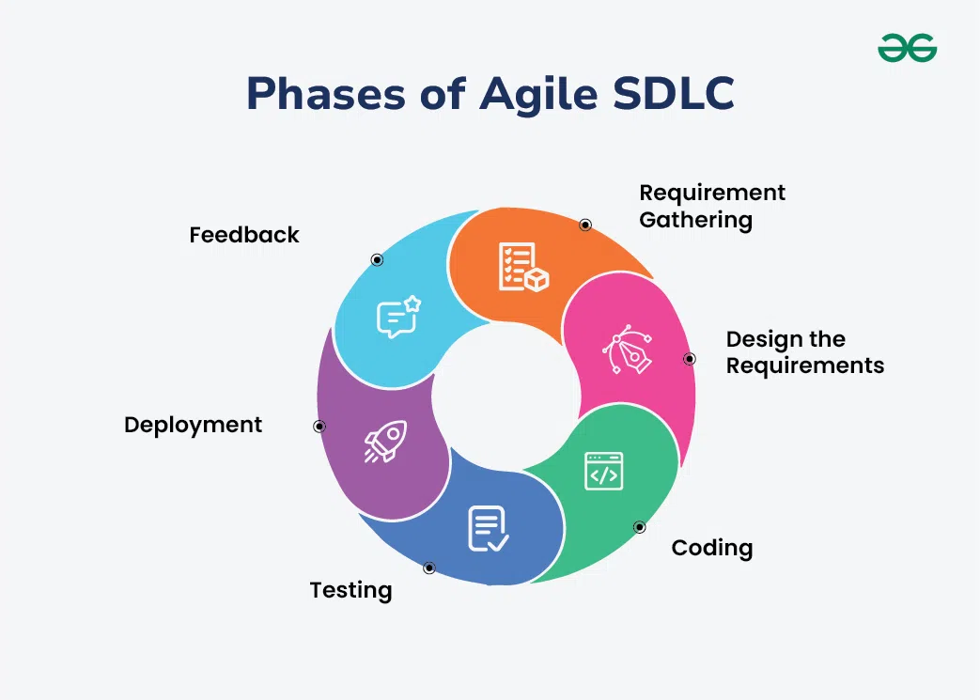

Figure 3.3.1 Agile Applications Development Life Cycle

The Agile Application Software Development Lifecycle (SDLC) provides the fundamental foundation for constructing the Web and Mobile-Based COPUS System, emphasizing user engagement, incremental development, and adaptability. Enhancements. It enables ongoing feedback, hence permitting the system to adjust according to genuine user requirements. The process is divided into six major steps.

**Requirement Gathering.** The project began with a thorough requirements analysis to determine the specific requirements of the faculty members and observers involved in the classroom observation process. The requirements were obtained by interviewing Mr. Jesthony (Active Learning Coordinator) and Ma'am Evelyn Juliano (Dean of CIT) to gain information on the issues encountered with the present manual process. The interviews revealed some of the important pain points, such as the use of a form to assess a CIT faculty member and the lack of real-time information. Additionally, direct observations were conducted to assess the methods used for recording and processing classroom observations. Based on the observations, the important system requirements were derived, ensuring the site would allow real-time logging, automated reporting, and multi-device usability.

**Design the Requirements.** Following the acquisition of necessary specifications, the second step was the development of the system architecture design, user interface, and database schema. Wireframes and system flow diagrams were created to identify user interactions with system components. The Input-Process-Output (IPO) Model was used to build a conceptual model for the acquisition, processing, and presentation of class observation data. The system design focused on developing an intuitive user interface by combining a clearly defined database with an interface that supports users.

**Coding.** Once the design phase was complete, the development phase came in an iterative sprint-based fashion. The system functionalities were built in incremental cycles to allow for early feedback and continuous refinement. The coding efforts were focused on building the most critical aspects of the system, such as user authentication, classroom observation logging, real-time analytics, and report generation. In addition, mobile compatibility was also offered, allowing observers to log classroom activity through both web and mobile interfaces.

**Testing.** The step of Quality assurance was an important part of the process of development. The stability and performance of the system was tested at different levels. Each module was unit tested to ensure that it worked as required. Then came the Integration Testing to ensure that system components, like data entry and report generation, were able to communicate with one another seamlessly. Lastly, User Acceptance Testing (UAT) happened with actual faculty and observers, to verify that the system actually matched expectations and would really work in practice

**Deployment.** The system was first tested to confirm the technology and minimize the risk during deployment and deployment followed a phased approach to ensure a smooth transition. It had an early stage pilot testing, which permitted few users to access the system with testing. The next step was to conduct training sessions for users to get used to the workings of the platform. After a successful pilot run, the entire system was deployed, replacing manual observations process with automated real-time data-driven solutions.

**Feedback & Continuous Improvement.** The last stage of the Agile process when user feedback was received and configurations were performed. Faculty and observers were invited to comment on their experiences with the system and to spot areas for enhancement. This is followed by regular system updates and maintenance to improve usability, fix bugs and incorporate new features based on user requirements. This iterative process will keep the Web and Mobile Based COPUS System high quality, user-friendly and focused on institutional objectives.

**Reasoning for choosing the SDLC Agile Development Model**

We chose the Agile Software Development Lifecycle for the development of the Web and Mobile-Based COPUS System due to of its ability to adapt and put users at its heart. In the early phases, the Agile methodology enabled the research team to conduct interviews and observations to obtain specific user requirements. As a result, we were still producing things in advance and not stuck, but we were flexible enough to adjust if something new came up. Agile allowed us to iteratively evolve the features of the system based upon real-time feedback, avoiding lengthy delays and wasteful work often associated with traditional models. Further, Agile's iterative methodology helped the team deliver usable prototypes early for cit faculty members, alc, slc, dean and administration to access the system as it was being developed but prior to full deployment. This meant that the probable errors during UX and system [tests] were minimized while improving the overall [stability] of the system as components were continued to be tested and improved. Furthermore, the model nudged the end-users to actively participate and build the sense of ownership thus increasing the prospects of successfully realising the newly proposed concept. Another major benefit was the ability to de-risk. The team, by conducting lots of testing phases, eliminated problems during an early stage reducing the chances of a catastrophic failure when deploying. The iterative nature of Agile also helped address the security vulnerabilities and usability concerns on time. In summary, the Agile Methodology played a pivotal role in the development of a COPUS system that is scalable, efficient, and easy to use. It allowed a transition from manual to automated observation methods that were true to the end needs of its users while providing room to improve upon this in the future.

**3.4 Conceptual Framework**

Figure 3.4.1 Conceptual Framework

**3.5 Data Analysis**

Pie charts are a natural way to visualize features of the COPUS data, and we focus our analysis on them. The following two pie charts are for the activity tally. On the other hand, a pie chart is another way of measuring the teacher activity tally that is used to you as an element in this visual, to show the kind of instructor way of teaching that the teacher adopts as a category in itself, such as the approach, method, strategy or technique used by instructor members. And to determine the effectiveness of the proposed system, t-Test using one-tailed test under .05 level of significance will be used to determine any significant improvement on the performance between the existing system and proposed system.

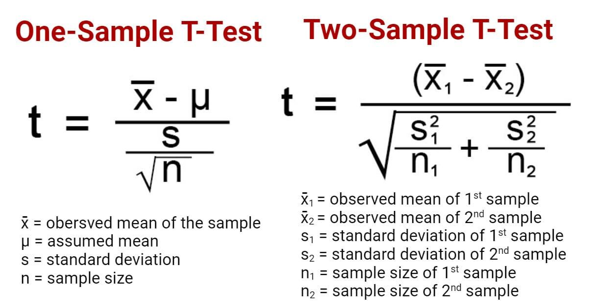

Figure 3.5.1 T-Test

In addition to statistical tools, percentage and average analysis is employed to quantify the occurrence of specific activities within the dataset.

**3.6 Description of the Existing System**

The current COPUS observation system follows a manual process that relies on paper-based documentation. Printed COPUS forms are used by CIT faculty observers to record and take notes on classroom behavior. The current system is only implemented and used the Administrator, ALC, SLC, DEAN and also the CIT Faculty Members. But there are a few problems like in data collection, manual transcription mistakes, slow report generation etc. Without access to the data in real time, classroom interactions are also hard to analyze. Also, there is no automated summarization of the observed behaviors or a visualization of trends in the observed behaviors.

**3.6.1 Data Flow Diagram of the Existing System**

**Administrator**

* Reviews and verifies the observation data.
* Ensures the accuracy of the recorded information.
* Generates reports based on the summarized observation results.
* Helps maintain the integrity of the evaluation process.

**ALC SLC Dean**

* Monitors the CIT faculty member's teaching methods.
* Records observations using the COPUS sheet by checking relevant columns.
* Generate formative report
* Provides feedback based on classroom activities and student engagement.

**CIT Faculty Member**

* The subject of observation in the COPUS process.
* Receives feedback and insights based on classroom behavior.
* View their personal COPUS results.
* Uses the data to improve teaching strategies and student engagement.

**3.6.2 Hardware Setup**

For the web and mobile-based implementation of the COPUS System, the following hardware is required:

* Personal Computer or Laptop – Used by faculty, observers, and administrators to access the system.
* Tablet or Smartphone – For observers to conduct classroom observations via the Android app.
* Printer (Optional) – For generating hard copies of reports.
* Stable Local Network – Ensures smooth connectivity between devices and the server.

**3.6.3 Software and Applications**

To fully implement the COPUS System digitally, the following software and tools are needed:

* Web Browser (Google Chrome & Microsoft Edge) – For accessing the web-based system.
* MySQL – Database for storing observation records, reports, and user data.
* Laravel – Backend framework for handling system logic, user authentication, and database interactions.
* React.js (Android App) – For the mobile version of the system used by observers.
* Bootstrap – For responsive and visually appealing web design.

**3.6.4 Personnel**

The Admin is mainly taking charge on the COPUS System in PHINMA-Araullo University South Campus. They manage the schedule of the observation of each CIT Faculty member.

The ALC SLC and CIT Dean are the observers. They will Observe and Evaluate CIT Faculty members in Classroom.

The CIT Faculty member is in charge of doing his best for teaching. They can also view the results after the evaluation process.

**3.6.5 Organizational Structure**

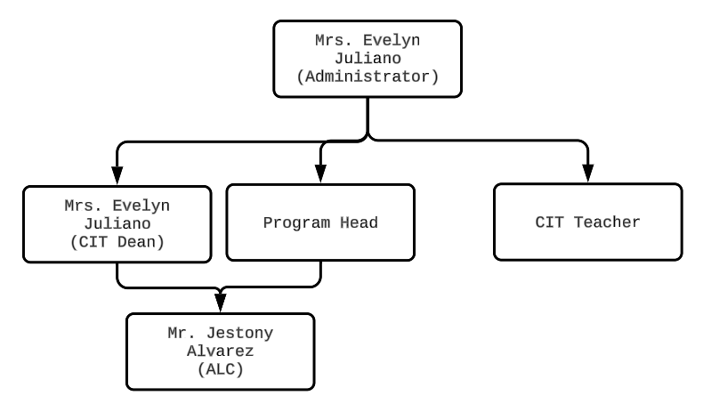

Figure 3.6.5.1 Organizational Chart

**3.6.6 Sample Forms and Reports**

**Release of Teacher’s End-of-Semester Developmental Reports and End-of-Sem Coaching**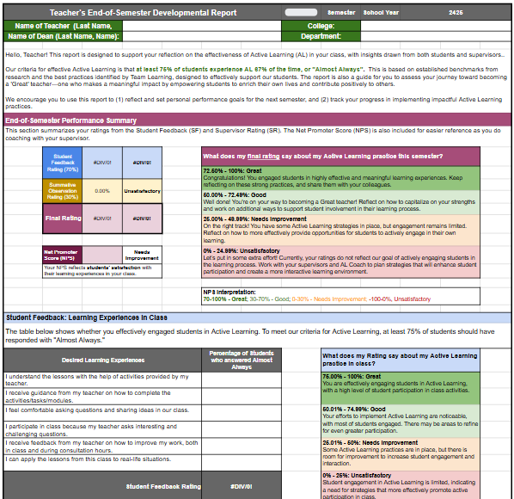

Figure 3.6.6.1 Release of Teacher’s End-of-Semester Developmental Reports and End-of-Sem Coaching

**Formative Classroom Observation and Coaching**

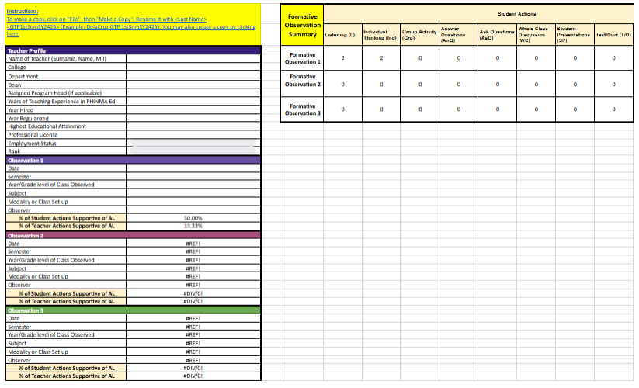

Figure 3.6.6.2 Formative Classroom Observation and Coaching

**COPUS Recording Observations and Tallying Results**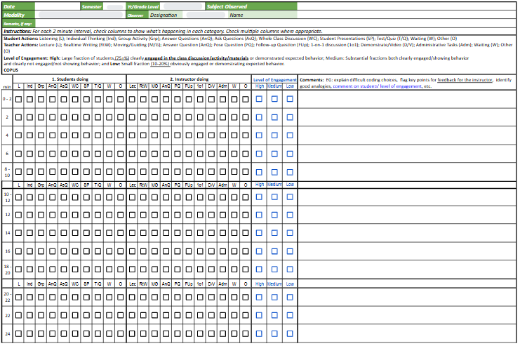

Figure 3.6.6.2 COPUS Recording Observations and Tallying Results

**3.7 Proposed System**

**3.7.1 System Architecture**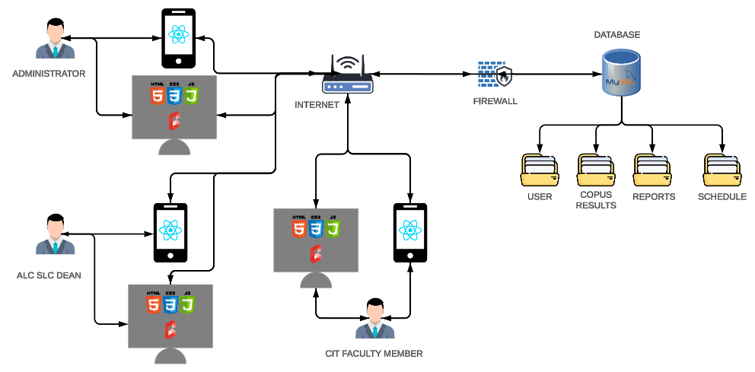

Figure 3.7.1.1 System Architecture

**Front-end Technologies**

Web Platform

* HTML, CSS, JavaScript
* Laravel Blade
* Bootstrap

Mobile Platform

* React Native
* Axios

**Back-end Technologies**

Backend Framework

* Laravel

Database

* MySQL

**Middleware/API**

Middleware Stack (Laravel API)

* Authentication Middleware
* CORS Middleware

API Stack (RESTful API)

* JSON
* Laravel (Backend API)
* Captcha
* Axios

**3.7.2 Context Diagram**

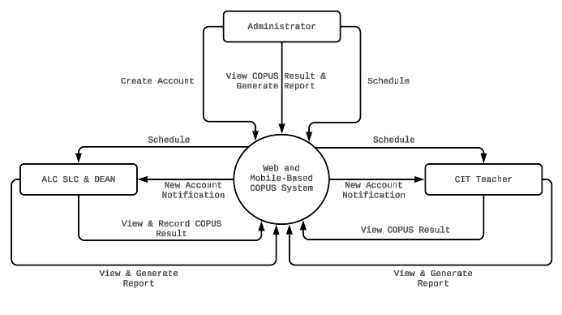

Figure 3.7.2.1 shows the Context Diagram of COPUS System

**3.7.3 Data Flow Diagram**

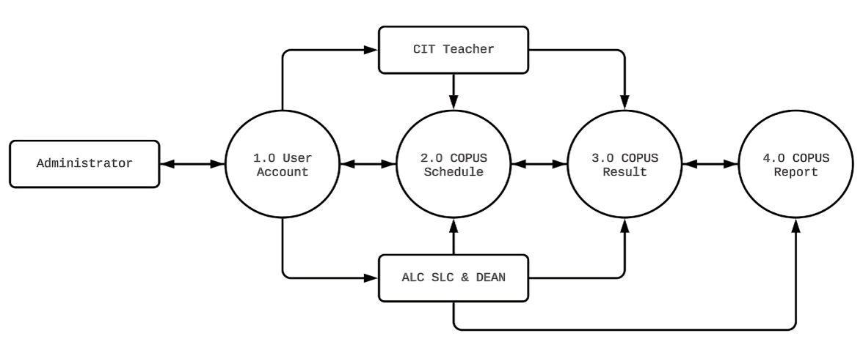

Figure 3.7.3.1 Data Flow Diagram

**1.0 User Account**

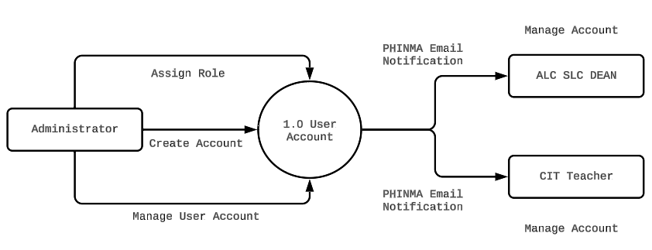

Figure 3.7.3.2 DFD for User Account

**2.0 COPUS Scheduling**

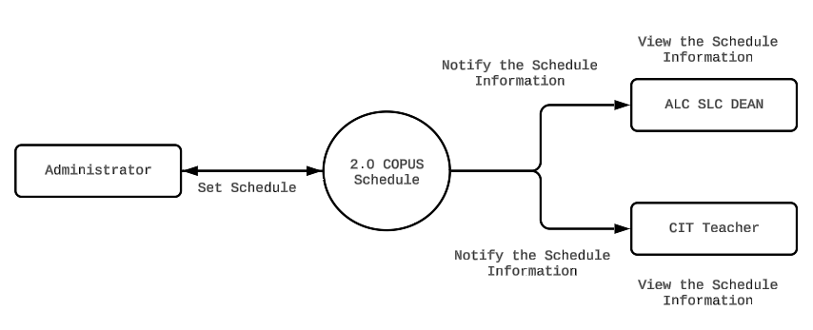

3.7.3.3 DFD for COPUS Scheduling

**3.0 COPUS Result**

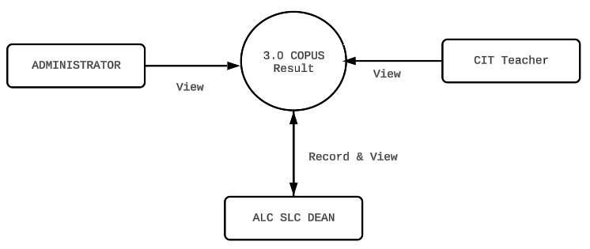

Figure 3.7.3.4 Data Flow Diagram for COPUS Result

**4.0 COPUS Report**

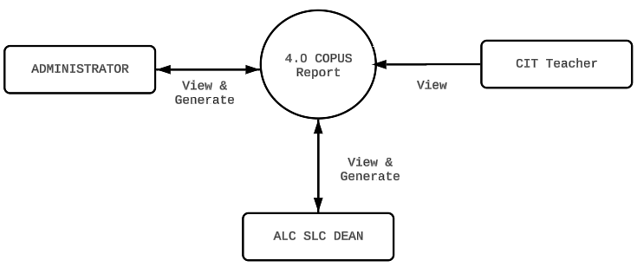

Figure 3.7.3.5 DFD for COPUS Report

**3.7.4 UML Use-Case Diagram (UCD)**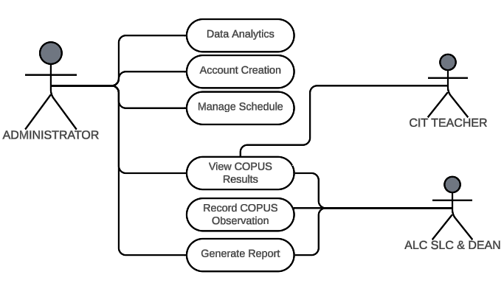

Figure 3.7.4.1 Use-Case Diagram (UCD

**3.7.5 Entity-Relationship Diagram (ERD)**

**(asan po?)**

**3.7.6 Modules Specification**

**(asan po?)**

**3.7.7 Hardware Requirements**

* Personal Computer or Laptop
* Smartphone
* Router

**3.7.8 Software Requirements**

* Browser: Chrome, Edge, Firefox, Opera
* Operating System: Windows
* IDE: VS Code
* Framework: Laravel Blade
* Scripting Language: Javascript
* Stylesheet: CSS

**3.7.9 Human Resource Requirements**

To efficiently operate the Web and Mobile-Based COPUS System, the following personnel are required:

1. **System Administrator** – Manages system configurations, security, and user access.
2. **COPUS Observers (ALC, SLC, Dean)** – Conducts observations, records data, and generates reports.
3. **Faculty Members** – Uses the system to receive and review observation results.
4. **Database Administrator** – Maintains the MySQL database, ensuring data integrity and security.

**3.8 Testing Activities**

To ensure the reliability and performance of the system, the following tests will be conducted:

1. **Unit Testing** – Verifies individual modules such as user authentication, scheduling, and data entry.
2. **Integration Testing** – Ensures proper communication between different system components.
3. **User Acceptance Testing (UAT)** – Engages faculty and administrators to validate the system’s usability.
4. **Performance Testing** – Measures system response time and behavior under different loads.
5. **Security Testing** – Identifies vulnerabilities, including SQL injection and unauthorized access.
6. **Compatibility Testing** – Checks system functionality across multiple browsers and mobile devices.

**3.9 Implementation**